Information on tourist spots around Ojiya

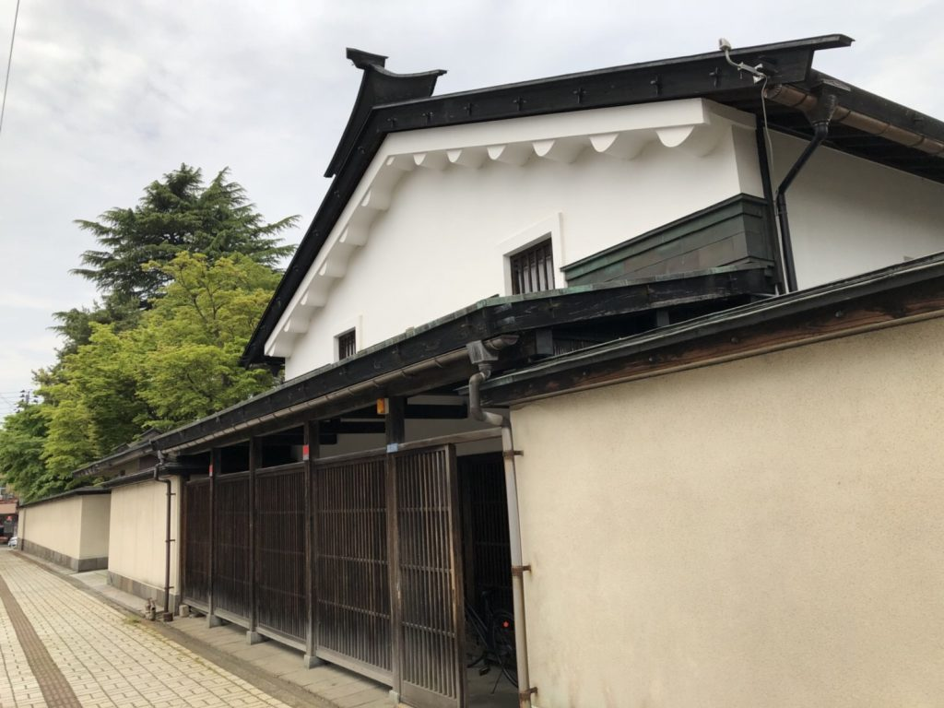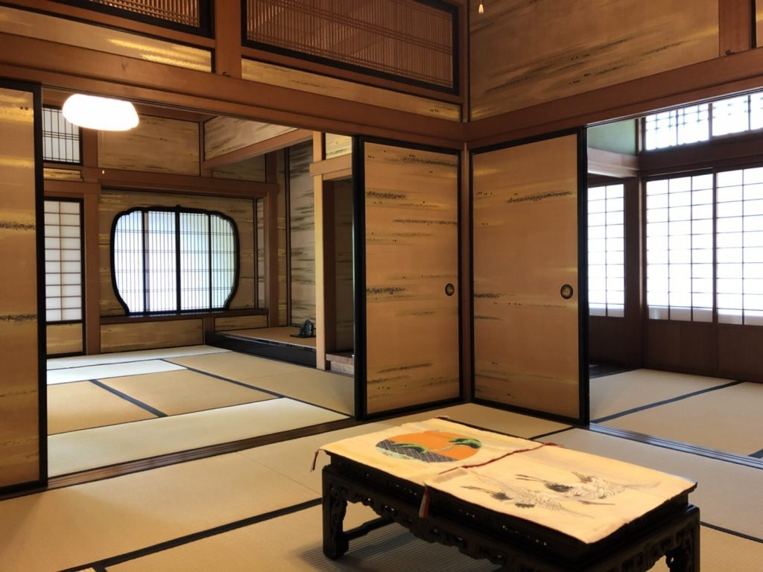
The residence of the Nishiwaki family

It is told that the Nishiwaki family started visiting Ojiya in 1688-1704. Soon they started the Ojiya Chijimi business and steadily developed foundation of their wealth. They utilized the surplus fund for land investments. During 1772 -1789, the head of the family, Yoshizou was the head of the town. Around 1789, he became one of the largest landowners in Ojiya. Later, the Bank of Nishiwaki was established by Nishiwaki family. In 1893, it was reorganized as “the bank of Ojiya.”, and it was merged into the Daishi bank in 1930.

The main building was built about 250 years ago and the new building is about 100 years old. The new building was designed by Tatsuzou Sone who was an architect well known for his use of western architectural styles in the later Meiji period. One of the features of the building is the beautifully detailed paintings of flowers and crane on Fusuma, a wood-framed sliding door and partition covered with thick paper.
The site area is approximately 5289m², the total floor space of the buildings is approximately 512m². In the garden, colored carps are gracefully swimming in the pond, and different kinds of stone lanterns surrounding the pond are beautifully matching with the Japanese style garden.

